

**Prepared for**:

**Date:**

**Prepared by:** Sumidha Ravindran

Document Name: Lab Manual

**Document Number: Amazon RDS MySQL Database**

**Contributor:**

***Table of Content***

***1 Objective…………………………………………………………………………………….3***

***2 Pre-requisite……………………………………………………………………………….3***

***3 Theory………………………………………………………………………………………..3***

***4 Create Amazon RDS MySQL Database………………………………………..4***

***🡪Management Console…………………………………………………………………4***

***5 Download and Install MySQL Workbench…………………………………..9***

***6 Connecting to the database in SQL Workbench……………………….…14***

***7 Writing some Test Queries…………………………………………………………17***

1. ***OBJECTIVE***

In this Lab, we will learn how to create an AWS Relational Database Service (RDS) MySQL Database.

1. ***PRE-REQUISITE***

* Account in AWS
* Create RDS MySQL
* Download MySQL Workbench

1. ***Theory***

***Why to Migrate Database to Cloud?***

Migrating from on-premise databases to the cloud gives businesses more flexibility and scalability, as well as faster infrastructure deployment, consumption-based pricing, and access to more database management systems. Moving databases, on the other hand, is often the most difficult element of a cloud migration, necessitating downtime, rethinking of data schemas, and remodelling of applications.

***What Amazon RDS?***

Amazon Relational Database Service (Amazon RDS) makes it easy to set up, operate, and scale a relational database in the cloud. It offers scalable capacity at a low cost while automating time-consuming administrative activities including hardware provisioning, database setup, patching, and backups. It allows you to concentrate on your applications, ensuring that they have the high performance, high availability, security, and compatibility that they require.

Amazon RDS provides you with six familiar database engines to pick from, including Amazon Aurora, PostgreSQL, MySQL, MariaDB, Oracle Database, and SQL Server, and is available on multiple database instance kinds - optimized for memory, speed, or I/O. You can quickly migrate or replicate your existing databases to Amazon RDS using the AWS Database Migration Service.

1. ***Create Amazon RDS MySQL Database***

***🡪Management Console***

**Step-1**

You need to create an AWS Account.

**Step-2**

Once you create your account, login to AWS console.

**Step-3**

On the search bar of the Management Console type RDS. Then Navigate to RDS.

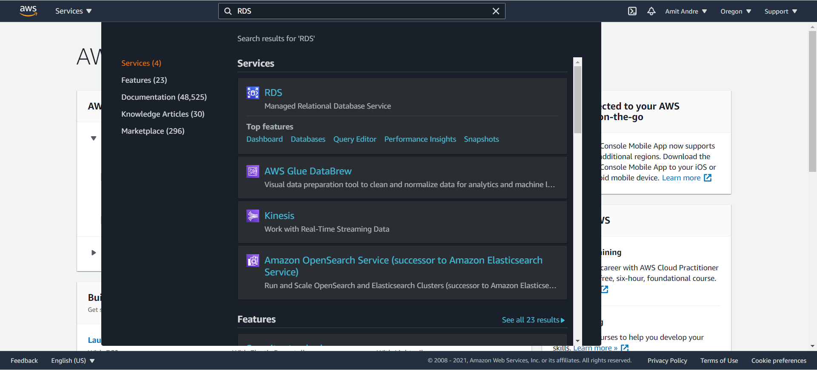

**Step-4**

Now once you click on RDS, you can see an option to Create Database.

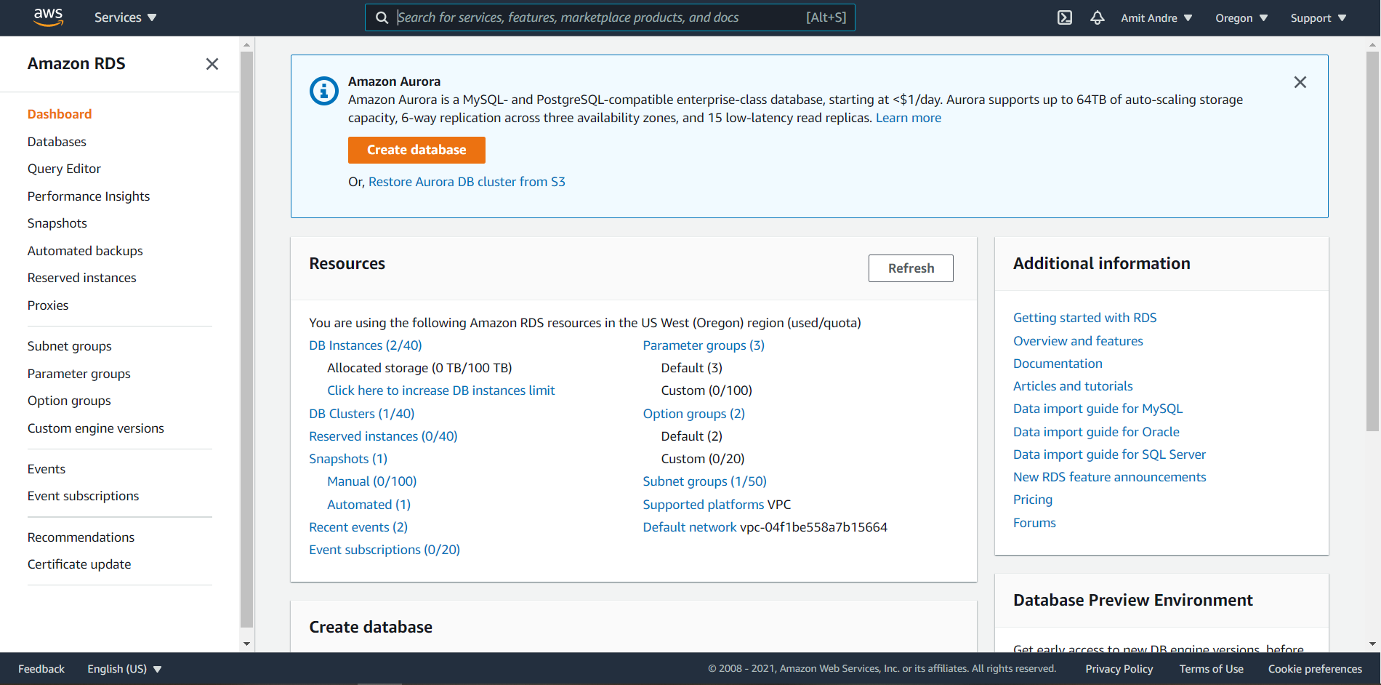

**Step-5**

Now it’s the time to choose your configurations.

* Choose a database creation method- Standard create
* Engine options- MySQL
* Version- MySQL 5.7.33

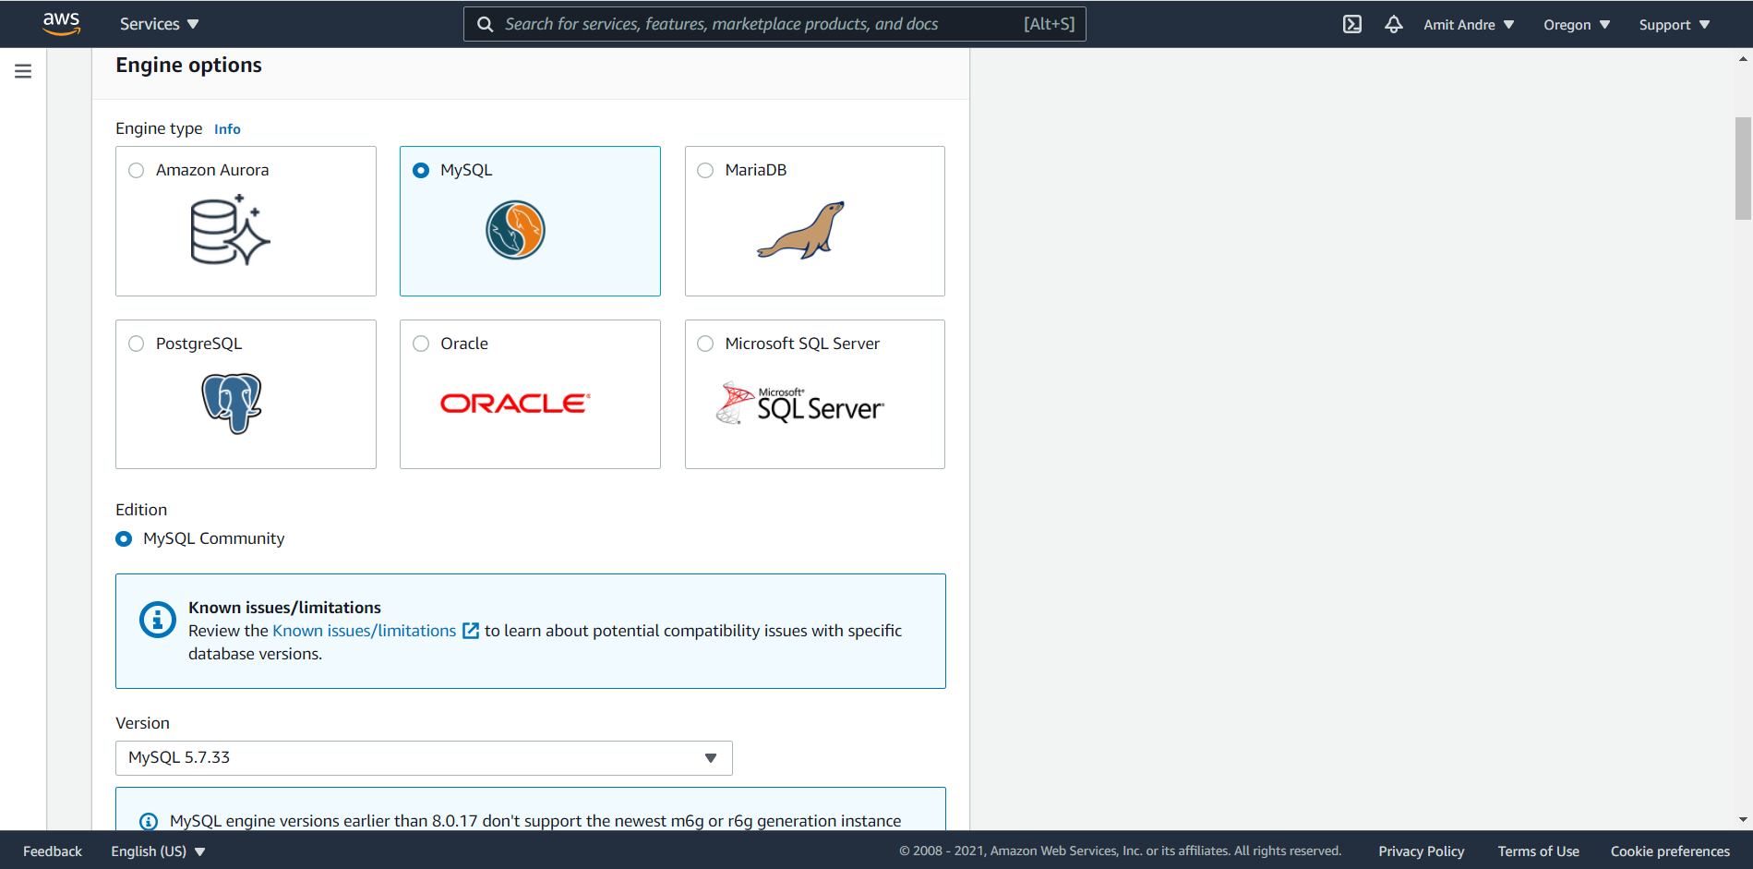

* Templates- Free Tier

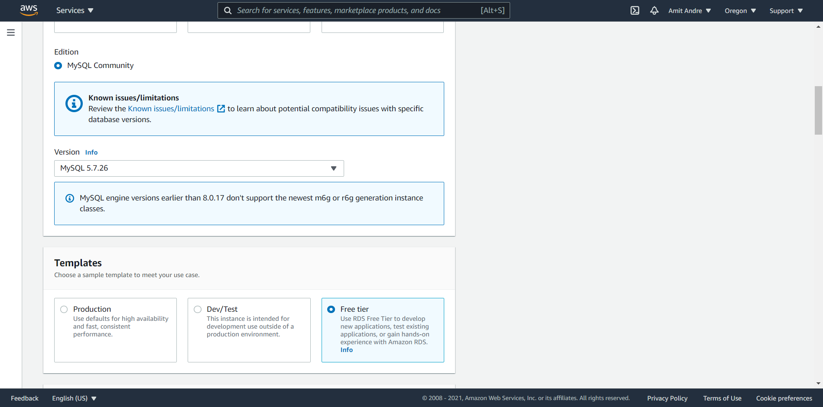

* Settings

Set the Master user name as **admin**. You can either auto generate your password or set your own password.

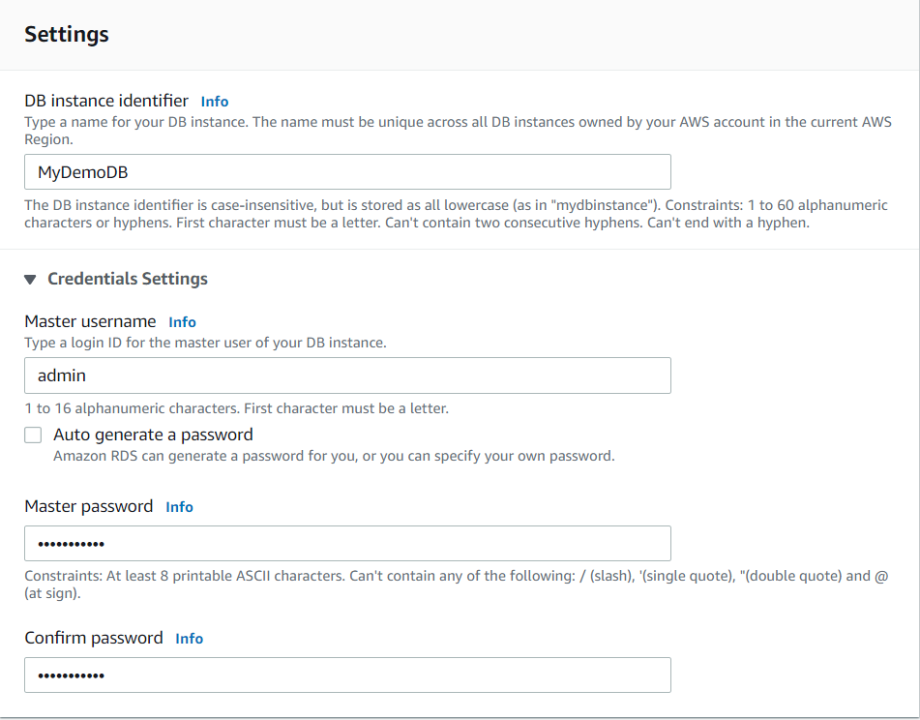

* DB instance class- Keep it default

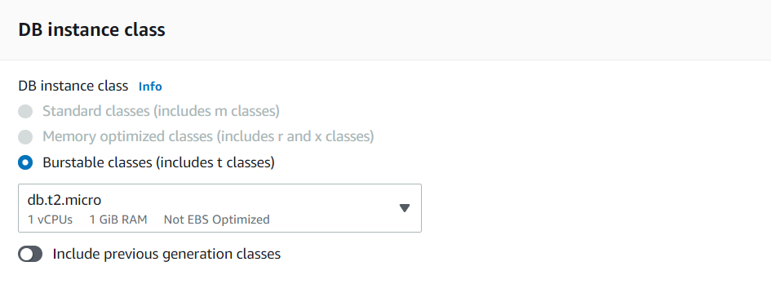

* Storage- Keep the storage settings default

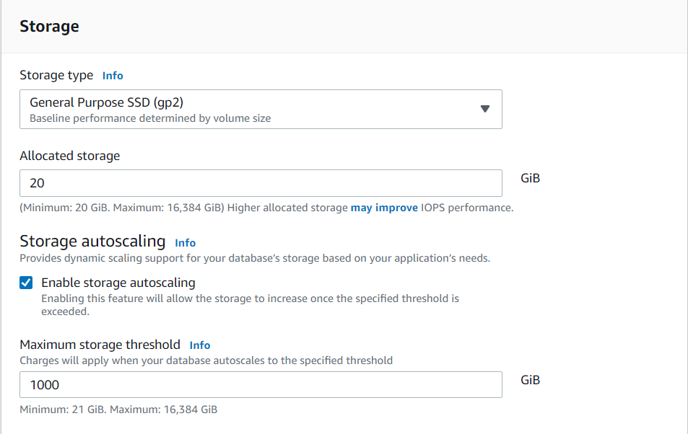

* Connectivity- Enable Public access. If you have your VPC security group select that or keep it default. Set the Availability Zone.

**NOTE: You should be very careful while choosing the connectivity. Whether you want to give public access or not.**

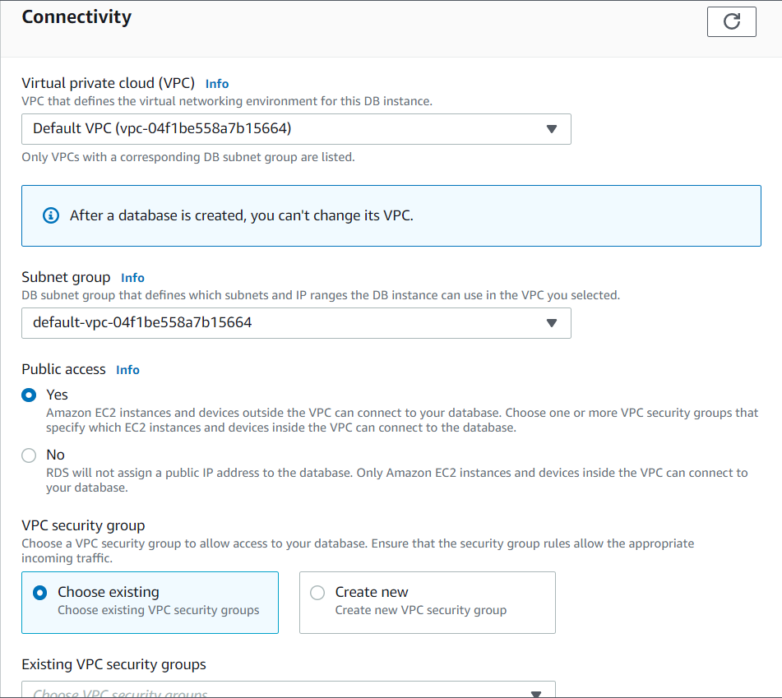

* Database authentication- Password authentication

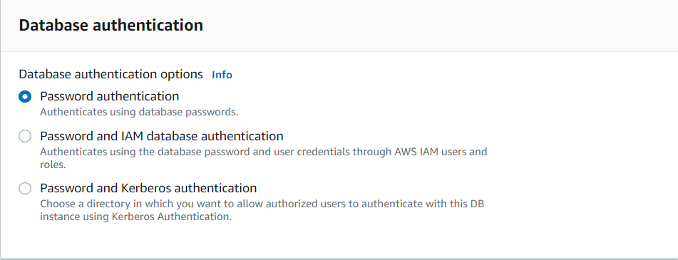

* Finally click on **Create database**. After that, you can see that your database is being created.

**NOTE: It will take couple of minutes to create.**

* Now You can see the status of the instance as Available. You have successful created a MySQL database on Amazon RDS.

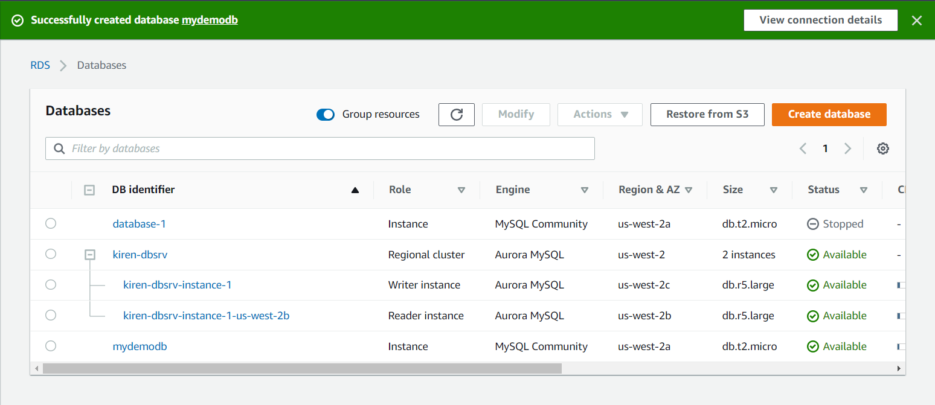

* Now you can see the database is created. Copy the endpoint to connect to MySQL DB.

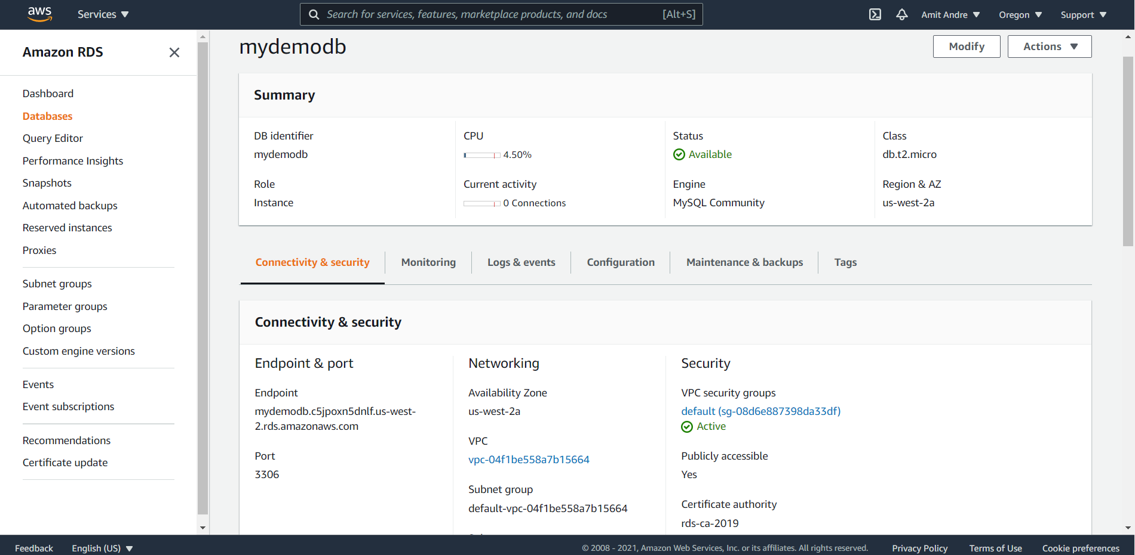

1. ***Download and install MySQL Workbench***

**Step-1**

* Use the link below to download MySQL Workbench

https://dev.mysql.com/downloads/workbench/

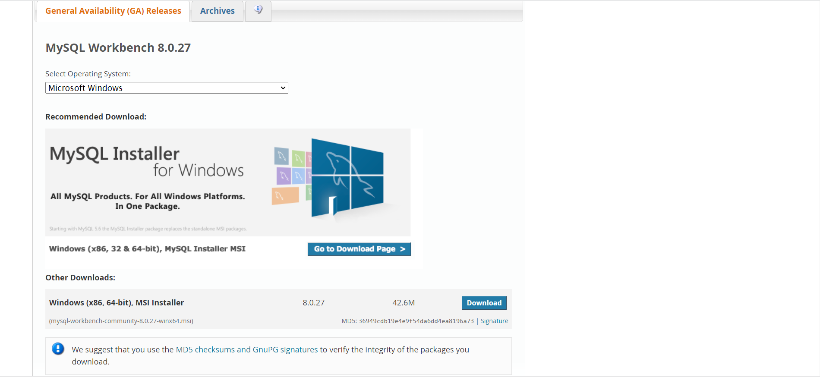

* Select your Operating system then Click on Download.

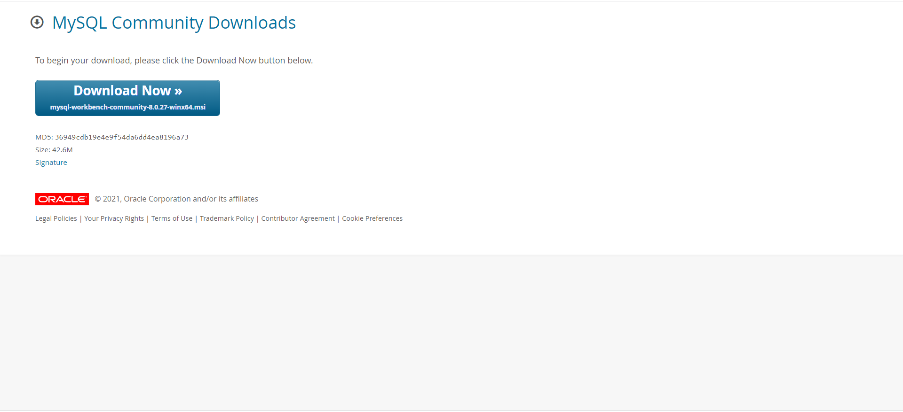

**Step-2**

* Follow the following steps to install the MySQL Workbench.

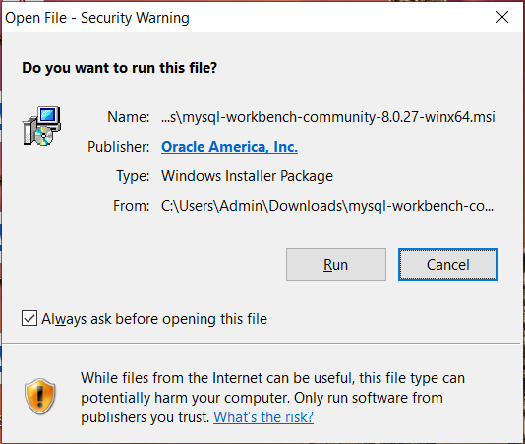

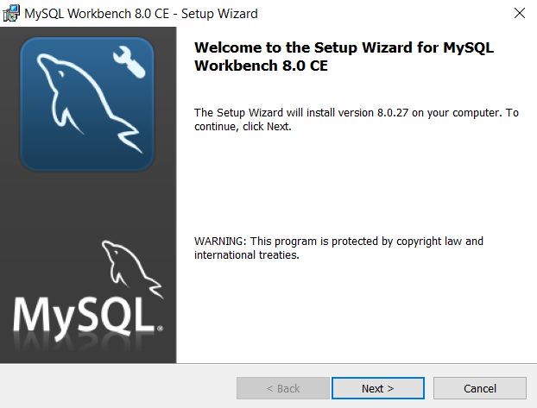

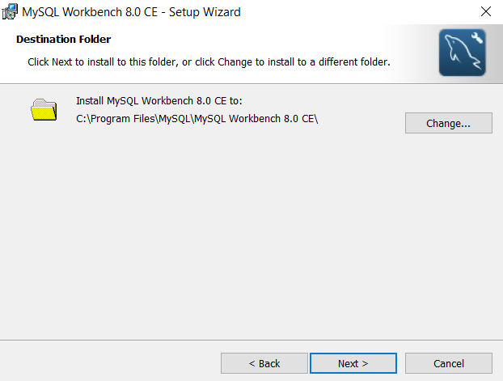

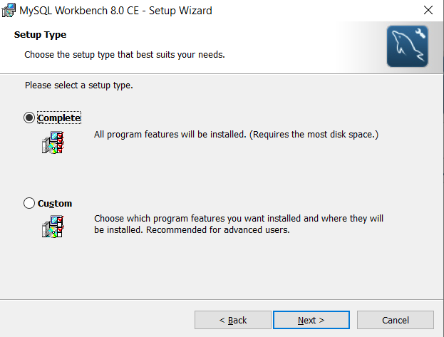

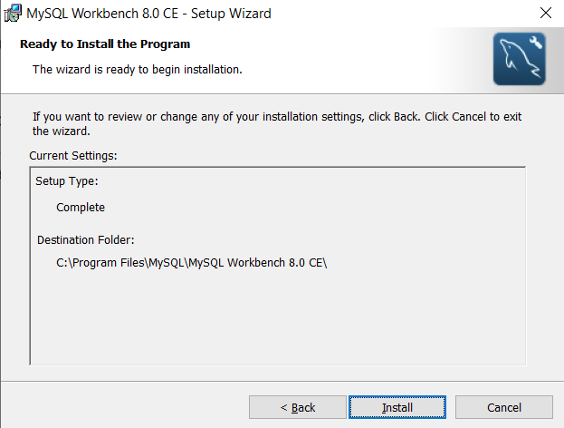

***6 Connecting to the database in SQL Workbench***

* Open MySQL Workbench. Click on the ‘**+’** sign to setup new connection.
* Enter connection name
* Paste the endpoint that you had copied earlier against Hostname.
* Click on **Store in Vault** and enter the password.
* Click on Test Connection.

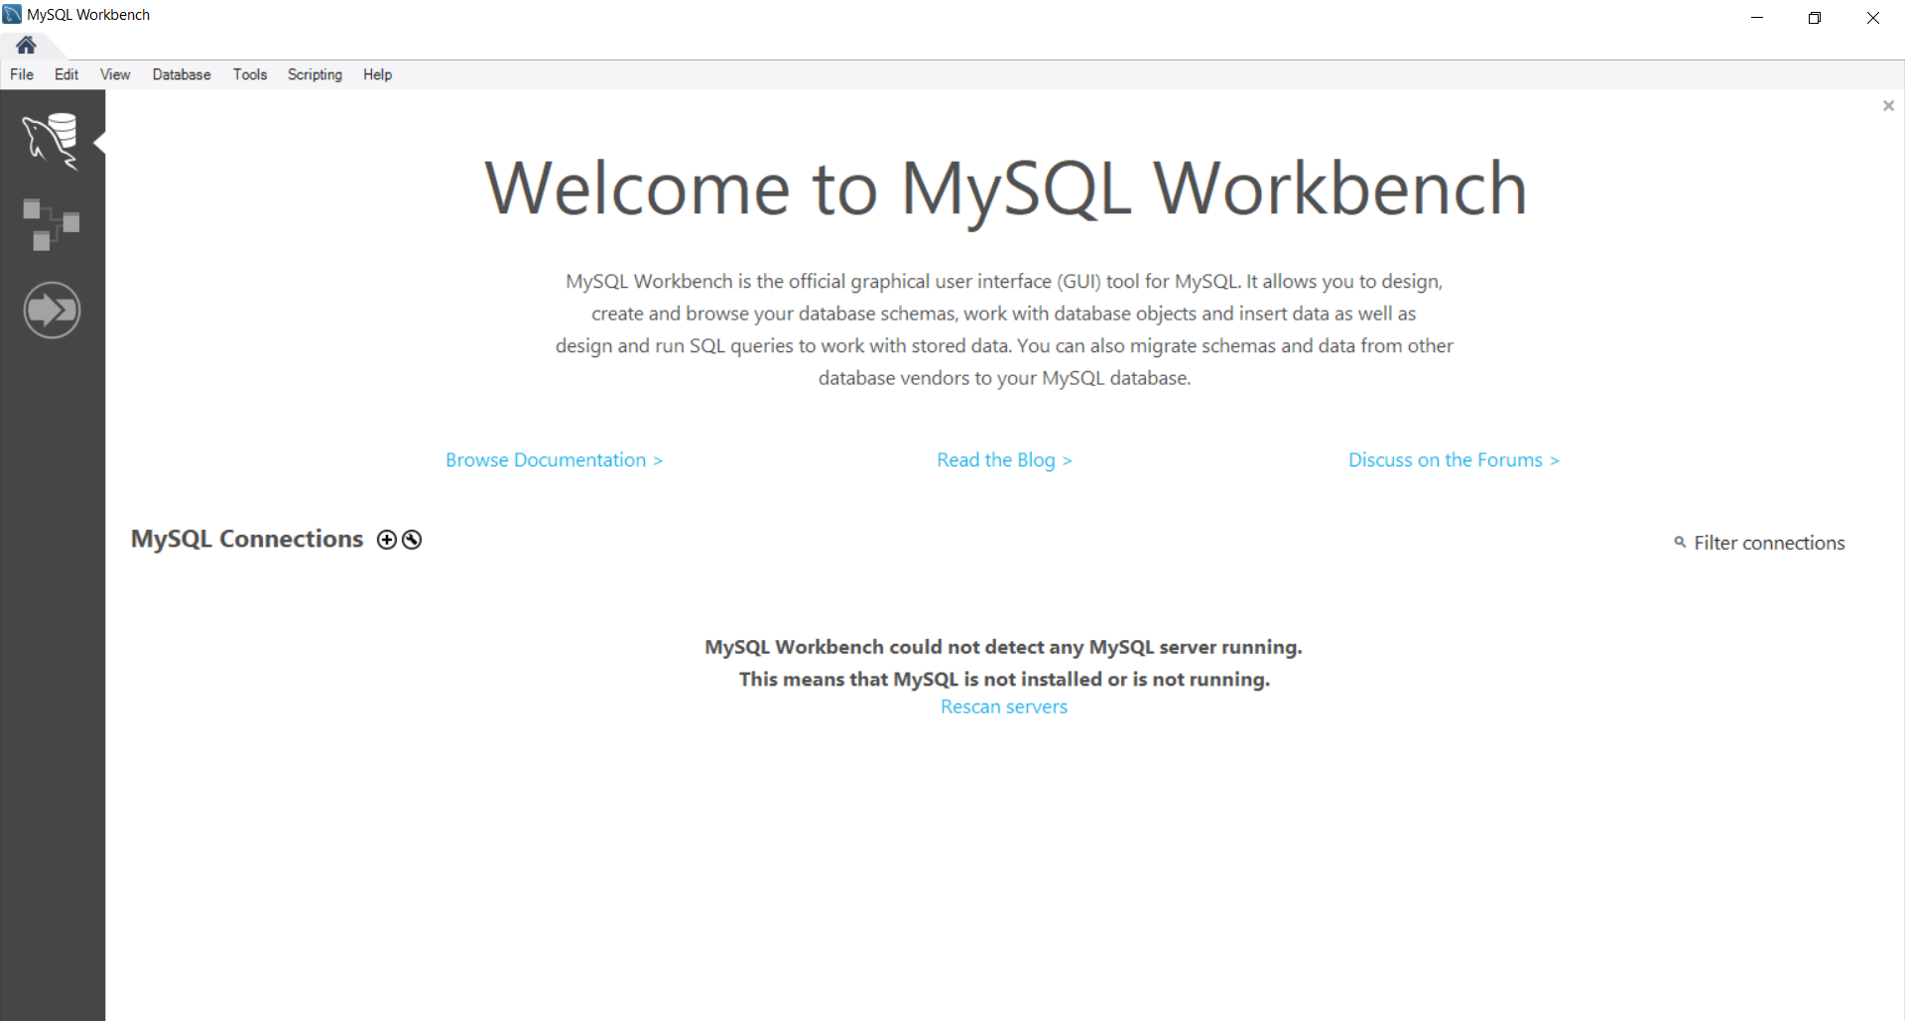

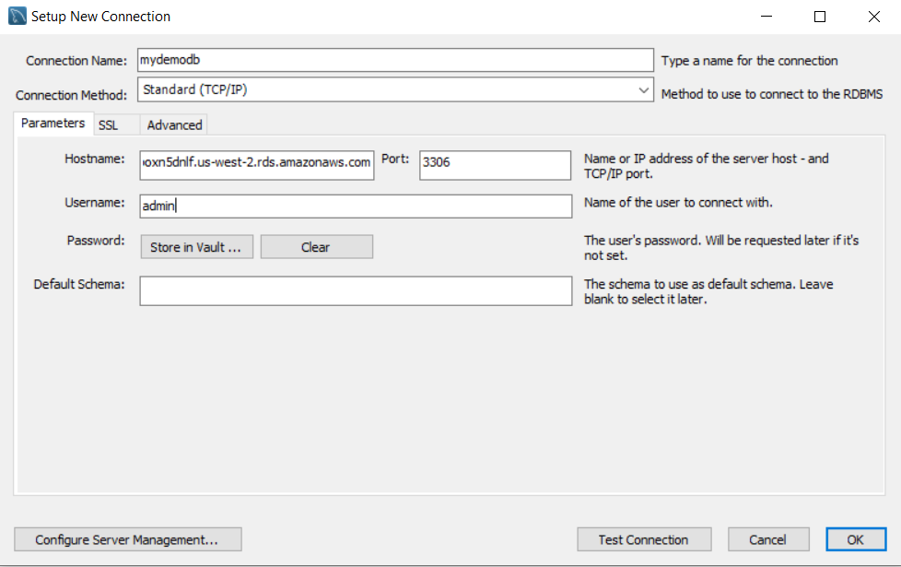

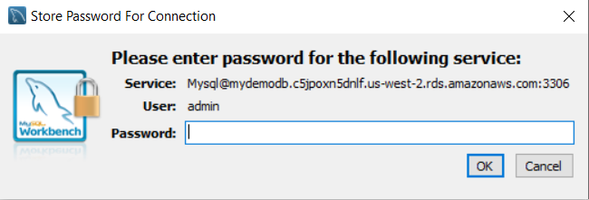

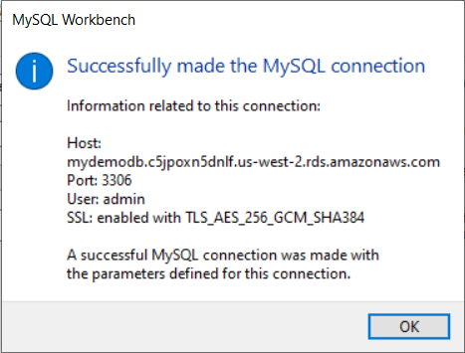

**Note: If you get an error while connecting, consider the following steps.**

**Step-1**

* Click on the VPC security group.

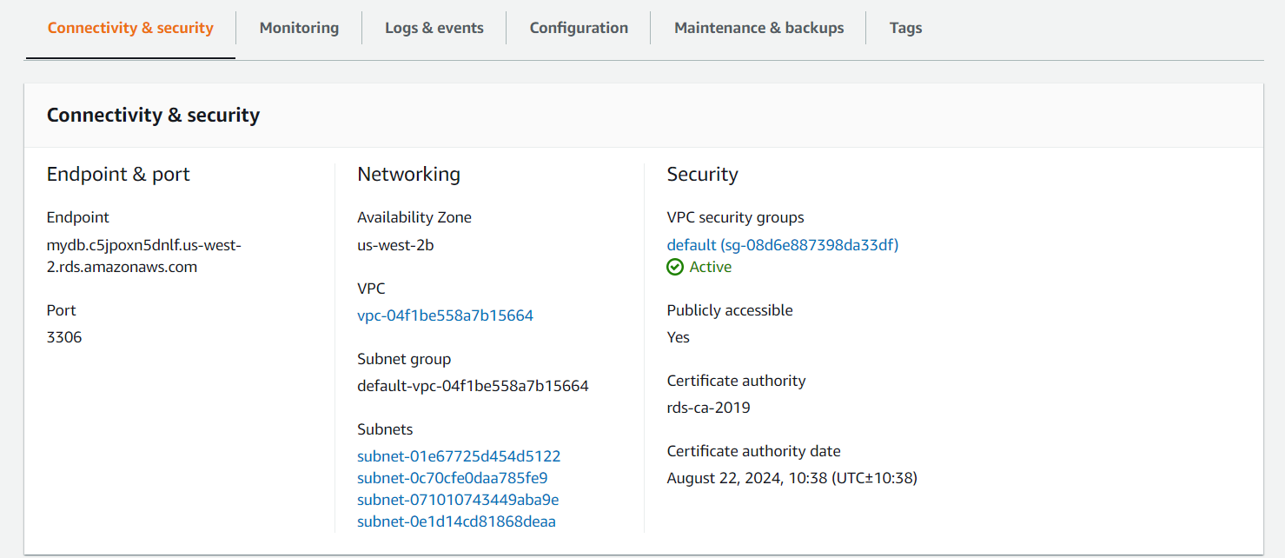

**Step-2**

* Navigate to Inbound rules.
* Click on Edit Inbound rules.

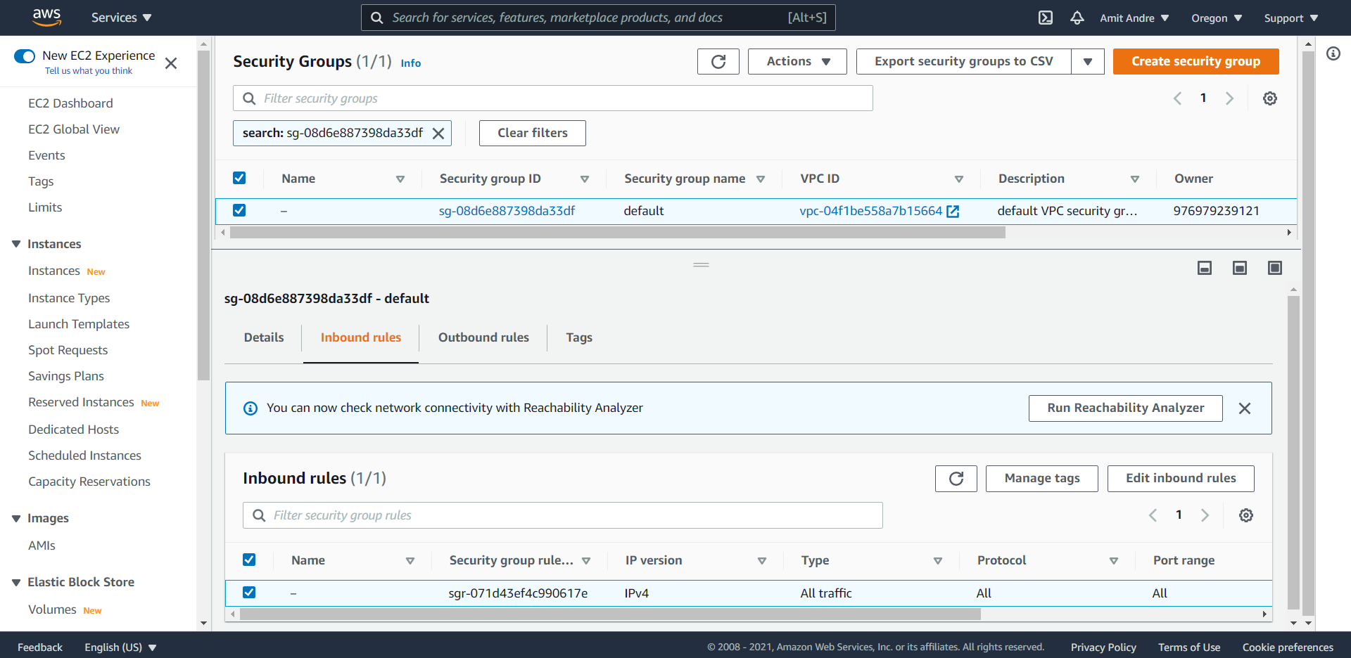

**Step-3**

* Click on **Add rule.**
* Set type -All traffic.
* Source -Anywhere IPv4.
* Save the rule.

**Now try again to connect.**

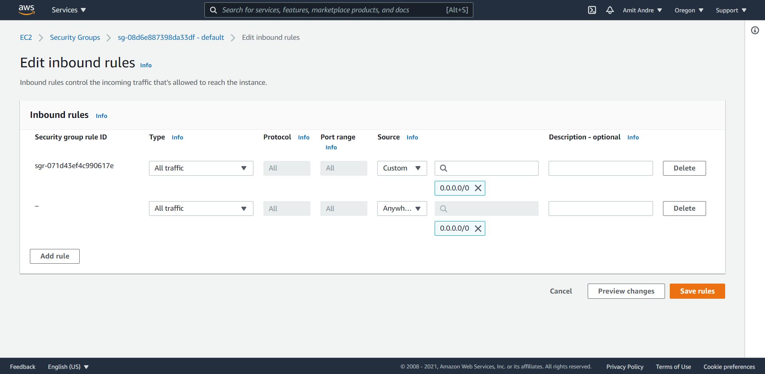

1. ***Writing some Test Queries***

